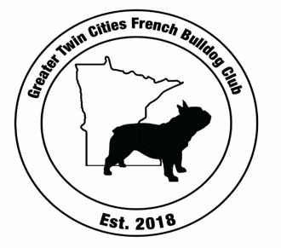
Greater Twin Cities French Bulldog Club
2023 Renewal Application

Dues: Individual Membership: $15 ; Family: $20 (household of two adults over age 18 years old)
Please Send by January 1st, 2024 to: GTCFBC, 118 Heritage Trl, Houlton WI, 54082
Please Type or Print Your Responses Your
Applicant’s name (s): _________________________________________________________________
Address: ________________________________________City: _______________________________
State:_________ Zip: ________Phone: Home:___________________ Cell : ______________________
Email: __________________________________________
Signature: ______________________________________________ Date: ______________________
Your Signature is required to allow for GTFBC to contact you by email and corresponds as the club member sees fit by email.
Signature: ________________________________________ Date: ____________

I ___________________agree to follow the rules and bylaws of the AKC Standards of the French Bulldog breeding/ health testing and the rules of the Greater Twin Cities French Bulldog Club.
Please initial Yes_____ No____

What would you like to help the club with?

- Matches/ Specialty Show
- Ring Steward
- Fundraisers
- Letters/ Website
- Rescue group
- Sunshine Group (sending out cards)

Other (please indicate how you’d like to help):______________________________________________

I would like to include a tax deductible club donation in the amount of:___________________________
(please include the indicated amount in your enclosed check)

